CHILDREN CENTRE PLANNING – Nursery to Reception
DATE:23/ 02/26
DATE:23/ 02/26 | ARTS & CRAFTS
Monday | Sunflower craft to see how tall we all are.
Tuesday | Hungry Caterpillar hats.
Wednesday | Flower pictures.
Thursday | Sunflower Pictures.
Friday
Themes / Links to School Curriculum:
Life cycles
Butterfly and hungry caterpillar.
Additional experiences in which staff will prepare for children to engage with - these are both planned and spontaneous. These activities also keep in line with school themes and upcoming celebrations.
DATE:02/03/26
DATE:02/03/26 | ARTS & CRAFTS
Monday | Gingerbread man story and making pictures.
Tuesday | Symmetry butterfly/Life cycle
Wednesday | Planting sunflower seeds.
Thursday | Story characters and puppets.
Friday
Themes / Links to School Curriculum:
Life cycles
Seeds
Planting
World book day.
DATE:09/03/26
DATE:09/03/26 | ARTS & CRAFTS
Monday | Vase of flowers for Mother’s Day.
Tuesday | Hats decorated with Mother’s Day flowers.
Wednesday | Mother’s Day cards.
Thursday | Mother’s Day flowers.
Friday
Themes / Links to School Curriculum:
Mother’s Day 15th March

DATE:23/03/26
DATE:23/03/26 | ARTS & CRAFTS
Monday | Plates with frog life cycle.
Tuesday | Frog masks.
Wednesday | Frog puppets.
Thursday | Frog hats.
Friday
Themes / Links to School Curriculum:
Science week
Frog life cycle
Ponds and cycle life

DATE:16/03/26
DATE:16/03/26 | ARTS & CRAFTS
Monday | Making bird nests.
Tuesday | Making an Eid hat with jewels.
Wednesday | Colourful Eid collage.
Thursday | Eid diyas
Friday
Themes / Links to School Curriculum:
National story telling week
Healthy body and mind.
Eid 20th March Celebrations.

DATE:
DATE: | ARTS & CRAFTS
Monday | Yoga and stories.
Tuesday | Positive pictures.
Wednesday | Outdoor obstacle course.
Thursday | Monster collages.
Friday
Themes / Links to School Curriculum:
Library visits in school
Wellbeing and relaxation

DATE:
DATE: | ARTS & CRAFTS
Monday
Tuesday
Wednesday
Thursday
Friday
Themes / Links to School Curriculum:

DATE:
DATE: | ARTS & CRAFTS
Monday
Tuesday
Wednesday
Thursday
Friday
Themes / Links to School Curriculum:

KEY CARER WEEK – End of every term
The children will spend time with their Key Carers and participate in adult led games and activities (of their choice)
Monday | Key Group Game Day  Children to split into the two key carer groups indoor and outdoor (to swap halfway) and encourage the children to choose an activity or game of their choice.  This could be Tag, Playdough, stuck in the mud, Find the Treasure, Grannies Footsteps etc…
Tuesday | Key Carer Story Time  Children to split into the two key carer groups indoor and outdoor (to swap halfway). Indoor Story time with Key Person, Outdoor Play with activities of Key Group choice.
Wednesday | Key Carer Scrunchie Play!  Using the scrunchie, singing songs and using this game to learn about each other!
Thursday | Key Carer Painting.  Both groups will paint pictures to display on key carer board. Staff and children will discuss what activities they have enjoyed throughout the term.
Friday | Free Play! (Child Led)

Links to EYFS |  |  |  | Links to the Curriculum
- Personal, Social & Emotional Development |  | Making Relationships, Self-Confidence and Self-Awareness, Managing Feelings & Behaviour. |  | - English  - Maths  - Science  - Art and Design  - PE  Links to School Themes:  - Amazing Animals  - Change  - Roles in society  - Beyond our eyes  - Similarities and differences between religious and cultural communities in this country.  - Caring for nature.
- Communication and Language |  | Listening and Attention, Understanding, Speaking.
- Physical Development |  | Moving and Handling, Health, and Self-Care. Fine Motor, Gross Motor.
- Literacy |  | Reading, Writing.
- Mathematics |  | Numbers, Shape, Space and Measure.
- Understanding the World |  | People and Communities, The world, Technology
- Expressive Arts and Design |  | Exploring and using Media and Materials, Being Imaginative.
Enhanced Provision
Additional Resources / Equipment for children to get out. Resources / Equipment are added or changed in response to children’s interests.
Colouring Sheets  Plain Paper  Scrap Paper  Maths Sheets  Handwriting / CVC Sheets  Collage Materials  Scissors  Glue  Playdough  Outdoor Freedom | Barbies  Cars and garages  Dressing up  Jigsaws and games  Snap cards  Building materials  Dinosaurs  Animals  Action Figures  Roleplay Area |  | Skittles  Skipping ropes  Tennis Racket and ball  Bean bags  Chalks  Hula hoop  Building bricks  Sand / Water play  Balancing boards  Small World

KEY GROUPS AND KEYWORKERS
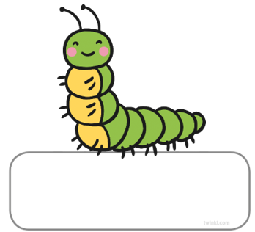

CATERPILLAR KEYWORKERS
(Nursery Children)
Debbie & Xaviera
BUTTERFLIES KEYWORKERS
(Reception Children)
Shelby & Leah

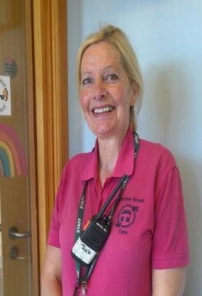
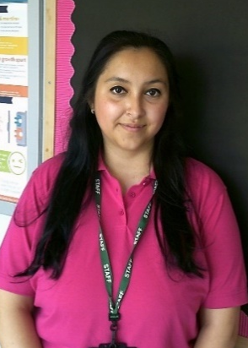

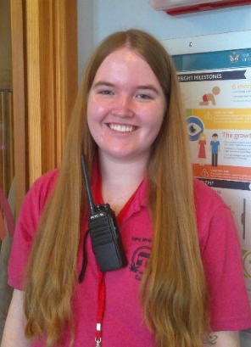
These groups are to help give your child a familiar adult to go to if they need any extra support. We also have frequent Key Worker weeks during session, to give each group a chance to bond and get to know each other!
Children will move up to the next group each September term.

