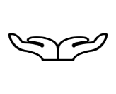

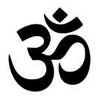
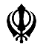

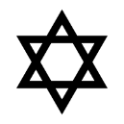
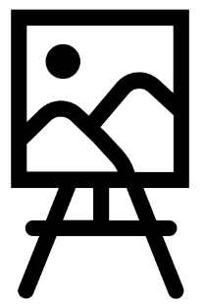

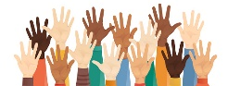

Music
We will be listening to some more music from Holst’s Planet Suite and singing songs linked to the topic. We will be composing and notating call and response rhythms, using Djembe drums and other instruments, and extending this work to include call and response melodies.
Art
In Art, we will be focusing on two formal elements of art and design: tone and colour. We will be doing this by creating watercolour paintings based on the Willow Pattern story. We will study
artists such as William Turner,
John Constable and Antoni
Gaudi.
Religious Education
This term we will be learning about Islam. We will be looking into the Five Pillars of Islam, the Qu’ran and the mosque as a place of worship. This will include a visit to a mosque in Worcester
PSHE
In PSHE, we are focusing on living in the wider world and exploring the question, what is a career? In health and wellbeing, we will be looking at why is sleep so important.
Online Safety
In our Online Safety lessons, we will be learning how to recognise our self-image and identity and how it contributes to our online reputation.

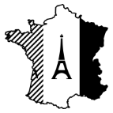
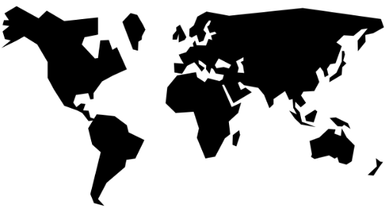
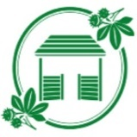
French
In French this term, we will be describing the personalities of ourselves and our families in addition to items of clothing and naming colours. We will also be looking at the types of weather as well as numbers from 1 – 60.

Geography
In Geography this term we will be focussing on how China’s Geography compares to the UK. We will be looking at human and physical geography including volcanoes and earthquakes.
Year 5
Spring Curriculum

Year 3
Autumn curriculum


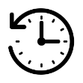

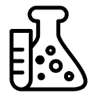
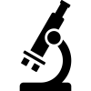
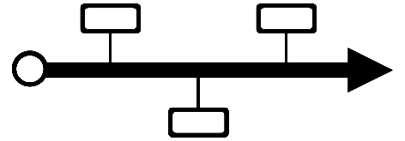

Computing
In Computing this term, we will be learning how to create different types of media, focusing on vector drawings using Google Drawings. We will learn how to layer the individual elements, grouping them and duplicating them to create
more complex pieces of work.
PE: In PE this half term, we will be doing tennis and gymnastics.
In Spring 2 we will continue with gymnastics and then focus on developing our cricket skills.

Science
In Science, we will focus on materials and their properties. We will compare and group together materials, use our knowledge of solids, liquids and gases to decide how mixtures might be separated, investigate dissolving and explore reversible and irreversible changes.
Design and Technology
In DT, we will be looking at earthquake-proof structures and building our own. We will put them through to tests to see how effective they are.
History
In History, we will follow an Historical enquiry to study the achievements of the Mayan civilization. We will focus on chronological understanding, comparisons with other civilisations and the exploration of a range of interpretations of evidence.

