







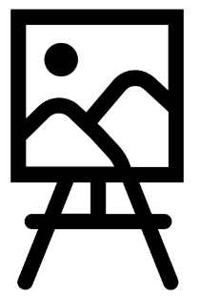

Art
In Art, we will be exploring the elements of texture and form through sculpture, studying the work of artists Khalil Chishtee, Tim Noble and Sue Webster.
Religious Education
We will be learning about Hinduism and what is means to be a Hindu. We will explore what is important to Hindus within their homes, families and communities.
Music
We will be singing all the Young Voices songs! We will then be using Vivaldi’s Winter and other weather music as inspiration for creating and notating soundscapes for poems, which convey mood and emotion.
PSHE
We will be learning about the uses of money, how to save, budget and invest in opportunities.
Online Safety
We will be learning how to recognise our self-image and identity and how it contributes to our online reputation.
Year 3
Autumn curriculum



French
This term, children will be encouraged to speak, write and recognise the following:
- Pets
- Negatives - I have got/I haven't got
- Colours of pets
- Numbers of pets/plurals

Year 4
Spring Curriculum

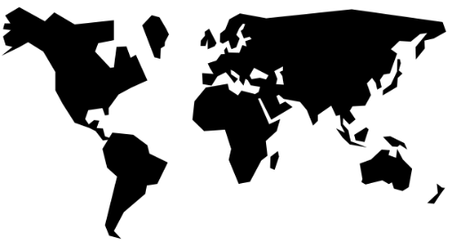
Geography
Children will build on their geographical knowledge by considering the location of the Ancient Egyptians and how they used their land. We will focus on the uses of the River Nile for Ancient Egyptian communities and why it was important to them.


Computing
Children will apply their knowledge and understanding of networks, to appreciate the internet as a network of networks which need to be kept secure. They will learn that the World Wide Web is part of the internet, and will be given opportunities to explore the World Wide Web for themselves in order to learn about who owns content and what they can access, add, and create. Finally, they will evaluate online content to decide how honest, accurate or reliable it is.

Science
Children will develop their scientific knowledge by exploring the states of matter. They will conduct investigations to study evaporation and condensation in addition to applying this learning to the water cycle.



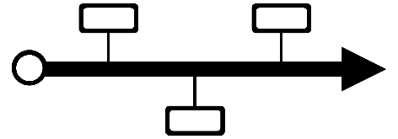


PE
During indoor PE, children will be learning how to communicate a story through dance. In outdoor PE, we will be exploring and developing football skills.
History
We will be going back in time to the Ancient Egyptian civilisation to learn about their life and communities. We will investigate their belief system, mummification and how they organised their society.

