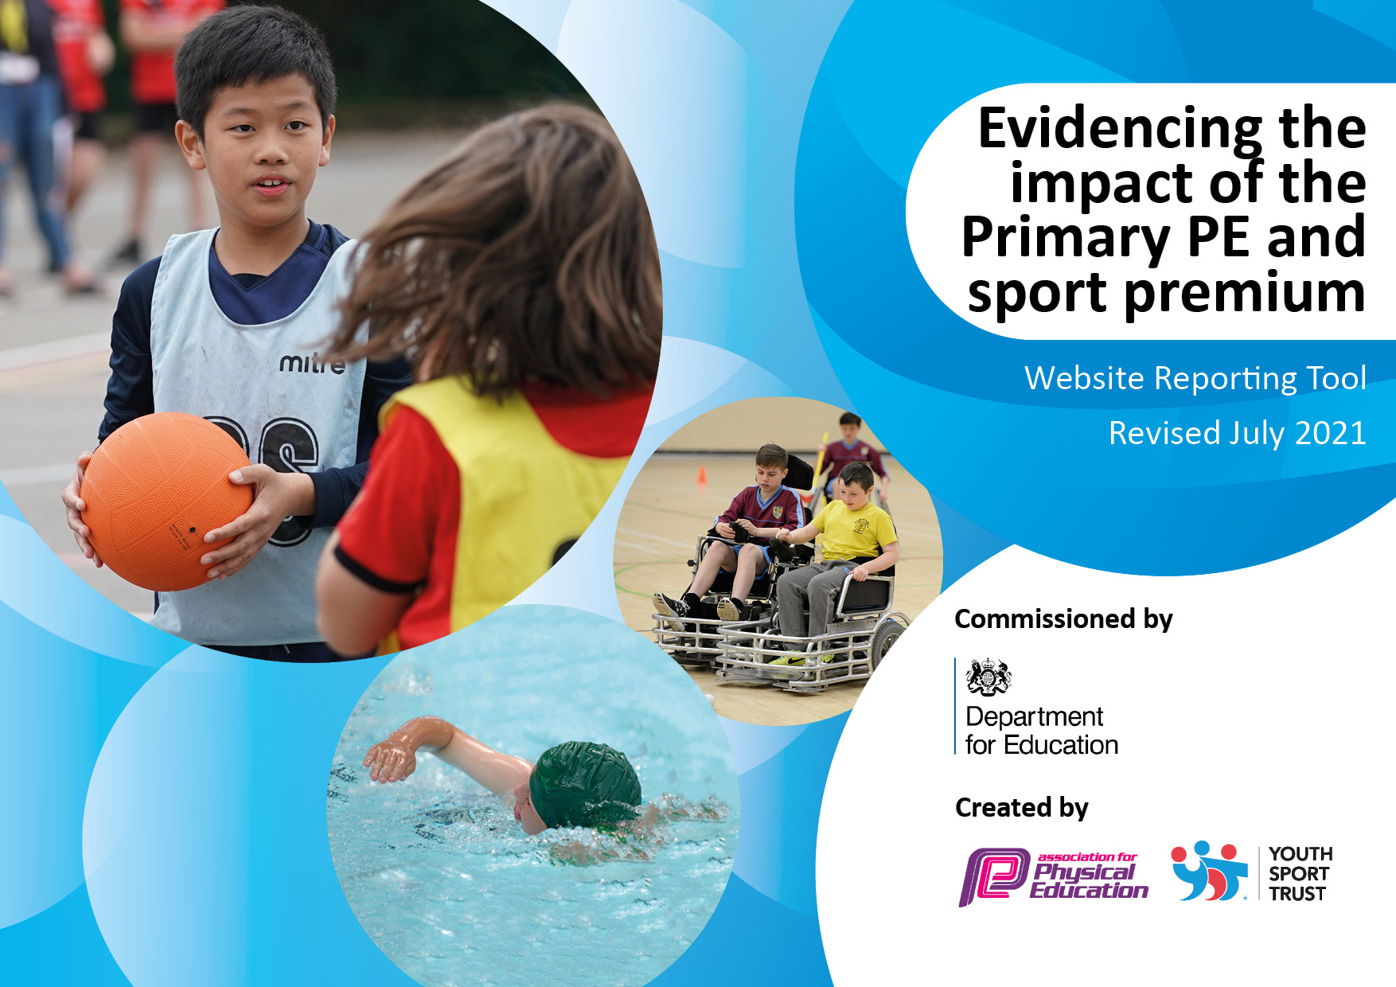
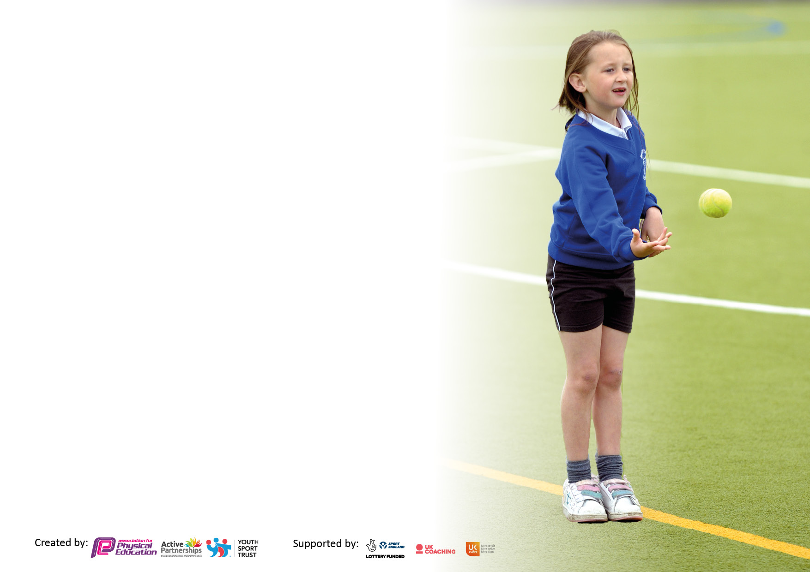

It is important that your grant is used effectively and based on school need. The Education Inspection Framework makes clear there will be a focus on ‘whether leaders and those responsible for governors all understand their respective roles and perform these in a way that enhances the effectiveness of the school’.

Under the Quality of Education Ofsted inspectors consider:
Intent - Curriculum design, coverage and appropriateness
Implementation - Curriculum delivery, Teaching (pedagogy) and Assessment
Impact - Attainment and progress

To assist schools with common transferable language this template has been developed to utilise the same three headings which should make your plans easily transferable between working documents.

Schools must use the funding to make additional and sustainable improvements to the quality of Physical Education, School Sport and Physical Activity (PESSPA) they offer. This means that you should use the Primary PE and sport premium to:

- Develop or add to the PESSPA activities that your school already offer
- Build capacity and capability within the school to ensure that improvements made now will benefit pupils joining the school in future years
- The Primary PE and sport premium should not be used to fund capital spend projects; the school’s budget should fund these.

Pleasevisitgov.ukfortherevisedDfEguidanceincludingthe5keyindicatorsacrosswhichschoolsshoulddemonstrate animprovement.Thisdocumentwillhelpyoutoreviewyourprovisionandtoreportyourspend.DfEencouragesschools to use this template as an effective way of meeting the reporting requirements of the Primary PE and sport premium.

We recommend you start by reflecting on the impact of current provision and reviewing the previous spend.

Schools are required to publish details of how they spend this funding, including any under-spend from 2019/2020, as well as on the impact it has on pupils’ PE and sport participation and attainment. All funding must be spent by 31st July 2022.

We recommend regularly updating the table and publishing it on your website throughout the year. This evidences your ongoing self-evaluation of how you are using the funding to secure maximum, sustainable impact. Final copy must be posted on your website by the end of the academic year and no later than the 31st July 2021. To see an example of how to complete the table please click HERE.


Details with regard to funding
Please complete the table below.

Total amount carried over from 2019/20 | £ 0 this year
Total amount allocated for 2020/21 | £ 21,390
How much (if any) do you intend to carry over from this total fund into 2021/22? | £ 12,189.54
Total amount allocated for 2021/22 | £ 21,390.00
Total amount of funding for 2021/22. To be spent and reported on by 31st July 2022. | £ 33, 579.54
Swimming Data
Please report on your Swimming Data below.

Meeting national curriculum requirements for swimming and water safety.

N.B. Complete this section to your best ability. For example you might have practised safe self-rescue techniques on dry land which you can then transfer to the pool when school swimming restarts.
Due to exceptional circumstances priority should be given to ensuring that pupils can perform safe self rescue even if they do not fully meet the first two requirements of the NC programme of study
What percentage of your current Year 6 cohort swim competently, confidently and proficiently over a distance of at least 25 metres?  N.B. Even though your pupils may swim in another year please report on their attainment on leaving primary school at the end of the summer term 2020.  Please see note above | tbc%
What percentage of your current Year 6 cohort use a range of strokes effectively [for example, front crawl, backstroke and breaststroke]?  Please see note above | tbc%
What percentage of your current Year 6 cohort perform safe self-rescue in different water-based situations? | tbc%
Schools can choose to use the Primary PE and sport premium to provide additional provision for swimming but this must be for activity over and above the national curriculum requirements. Have you used it in this way? | Intention is to Yes/No  Email sent to parents.

Action Plan and Budget Tracking
Capture your intended annual spend against the 5 key indicators. Clarify the success criteria and evidence of impact that you intend to measure to evaluate for pupils today and for the future.

Academic Year: 2020/21 | Total fund allocated: | Date Updated:
Key indicator 1: The engagement of all pupils in regular physical activity – Chief Medical Officers guidelines recommend that primary school pupils undertake at least 30 minutes of physical activity a day in school |  |  |  | Percentage of total allocation:
 |  |  |  | %
Intent | Implementation |  | Impact
Your school focus should be clear what you want the pupils to know and be able to do and about  what they need to learn and to  consolidate through practice: | Make sure your actions to achieve are linked to your intentions: | Funding allocated: | Evidence of impact: what do pupils now know and what can they now do? What has changed?: | Sustainability and suggested next steps:
To increase the opportunity for exercise and activity during break and lunchtimes  Opportunities to extend their activity after school  Reflect on pupil voice and offer a greater variety of equipment  Children to have fun and see activity as part of their daily lives. | Moki for the rest of school - | £175 – September – October  £175 – November-December  Free sessions earned due to performance at competitions  £140 – Autumn 1  £792 – Autumn 2  £1710.00  £180.00  £30.00  £300  Skipping Rope - £90  £604  £10, 320 | Latest update March 2022:  Table tennis table delivered February.  Available during lunchtime and has been used as a reward – e.g Year 6 Ingestre remainers  Ipod has been used effectively to promote activity with children at lunch. Many children from across the school can be seen dancing or moving to the music. Pleasingly, this includes those that don’t choose to participate in other activities and encourages more activity.  Lunchtime club participation has been successful this term. The highlight being the football club for year 4, 35 children regularly attended sessions focusing on fun and participation. Particularly pleasing that 12 (34%) of the children hadn’t taken part in a football club before and four of these are now pursuing it outside of school. All of the children expressed a wish to participate again when it was next available to them.  Unfortunately, this half term, Cricket club was interrupted by outbreaks in the chosen year groups. Whilst some sessions were completed not all were possible. As a result, taster sessions were introduced for individual classes. 270 children have taken part in this so far.  A targeted club will take place in Spring 2. 20 children unfamiliar with cricket have put themselves forward and will be prioritised for this club.  Orienteering Mapping of the School. Now that this has successfully been completed, the map has been shared for Orienteering sessions and for Geography. It will be used in March as part of an intra school competition involving children from across KS2.  Mapping also ensured that all children and staff were familiar with the intra school cross country route and meant that all classes had the opportunity to test the course before the event.  Family engagement programme applied for and accepted. First meeting attended and planning started.  The tunnelled climbing wall has arrived and is assembled in the EYFS area. The children have enjoyed using it daily. It promotes daily activity whilst also supporting the children with the aim for them to achieve their early learning goal in Physical development.  Moki watches purchased for 3 classes to trial how effective it could be. Children have responded well. Challenging themselves to beat their score and improve the number of steps they get each day.  Children have also responded well to challenges which can be run in class and across the school.  Due to this success we aim to purchase watches for the whole school. This way we can monitor who needs support, whilst allowing children to have an awareness of their activity habits.  Due to the success of the Harriers football club we are now also running one on a Wednesday for Year 3.
  Following pupil conferencing, it was decided to purchase:
  Carlton Table Tennis Class Pack
  T/821B Ultimate Outdoor Table Tennis table
  This will be put up by top courts and will offer a new opportunity for children to be active.
  P1080 Target net pack
  Ipod for lunchtime music – play through speaker
  Music credit
  Pay for lunchtime clubs
  Kidderminster Harriers
  Worcestershire County Cricket
  Personal challenges – rewards
  Challenges for year groups – values awards linked in.
  SKU: MOKI-0001 Moki band small
  SKU: MOKI-0004 Moki Reader
  Carriage
  Orienteering mapping of school
  Family Engagement programme
  Lunchtime activities
  Tunnelled Climbing Wall
  £210.00
  £2590
  £99.00
  £165.83
  £50
Key indicator 2: The profile of PESSPA being raised across the school as a tool for whole school improvement |  |  |  | Percentage of total allocation:
 |  |  |  | %
Intent | Implementation |  | Impact
Your school focus should be clear what you want the pupils to know and be able to do and about  what they need to learn and to  consolidate through practice: | Make sure your actions to achieve are linked to your intentions: | Funding allocated: | Evidence of impact: what do pupils now know and what can they now do? What has changed?: | Sustainability and suggested next steps:
To raise the profile of PE at Hagley Primary by increasing pupil involvement in a variety of sporting opportunities, giving pupils a voice to make changes and have a say in what sport we offer.  This will be initiated through a Sports Crew who will be the face of PE at Hagley and through continued links between the PE and core curriculum (e.g Science, DT and healthy eating).  We will also focus on upskilling staff so that they are confident and able to deliver effective lessons for all children. | PE Coordinator to be freed to lead pupil voice sessions across the school  Sport Council – PE coordinator to arrange meetings and action plans children put forward.  Support children in leading assemblies and encouraging other pupils to participate in activity.  Staff CPD sessions – linked to PE Hub and WFSSP to act on feedback from staff questionnaire regarding areas of support.  New kit purchased to help create pride in representing the school.  Resources to improve the quality of lessons and assist in the quality of sessions and the outcomes for children.  Super-Lite Gym Mat B (2m x 1m x 32mm)  Carriage  046898 Horizontal Gym Mat Trolley Large | Cover for PE lead - £1700 - total  Sport Council badges £42.50  WFSSP training Sports Crew Training – included in partnership cost.  PE Hub £500  PE Primary Ltd £325  £8.42  £32.50  £21.58  £265.80  £21.90  £82.80  £12.00  £40.00  £25.00  £35.94  £35.76  £35.70  £35.80  £11.95  £47.00  £65.00  £270.00  £40.00  £11.95  £75.00  £11.95  £285.00  £9.96  £9.00  £1660.00  £24.00  £52.00  £260.00  £22.00  £22.00  £22.00  £22.00  £16.00  £110.00  £750.00  £4.00  £431.92 | Autumn Update  Pupil voice sessions have taken place in Autumn Term – children were able to share what they thought was going well in PE and what they felt needed development.  After reviewing how the Sports Council will be used this year, taking advice from other schools, and seeing how it can be used effectively. A Sports Council Presentation has been shared with staff and a meeting will take place with elected children in January  First session has been conducted and children are gathering ideas from their class on how to get people more active.  PE Hub and PE Primary Limited Resources have been purchased. PE Hub ensures that lessons well planned and sequenced. We have also introduced a powerpoint slide to complement the learning to help children spot the links between lessons. Also, magnifying the importance of the skills they are learning.  Sports board and assemblies used to promote sport, often linking it to the school values.  New resources purchased to improve the quality of provision for the children and assisting staff in producing good quality sessions.
  Carriage - Box | 8.42
  Embroidered Badge | 32.50
  Large Printed Number | 21.58
  50680401JR - Tureis Shirt | Short Sleeve | 265.80
  54241309JR - Antilia GK Shirt Long Sleev | 21.90
  522309JR - Mesa Hero Shorts | Black | 82.80
  513909JR - Cassiopea Goalkeeper Shorts | | 12.00
  5907209JR - Rayon Socks | XS | Black [PQ | 40.00
  5909809JR - Rayon Socks | Small | Black | 25.00
  MB13 25 X MIDI BLADE BADMINTON RACKET | 35.94
  B9085 Midi blade 4.3 badminton racket | 35.76
  P705/YLW Foam sponge ball 7cm yellow | 35.70
  TB12 Slazenger 5 Dozen top grade bucket | 35.80
  Carriage | 11.95
  P423 Bat and ball pack | 47.00
  A4131 Bull nose foam javelin pack | 65.00
   | 165.83
    MB93 10x slazenger tennis rackets 21" | 270.00
    P314 Coated foam balls 9cm | 40.00
    Carriage  B1352/M carlton white shuttle pk medium  Carriage  N1074 Kooga centre netball pack size 4  Carriage | 11.95
   | 50.00
  S1418 Space markers x 50  F5101 Folded aluminium small sided goals  B1202 Small slazenger bag black  O1007 Control punches series A  R1070 Rounders set Primary starter  N1068/RY Kooga netball girls bibs royal  N1068/S Kooga netball girls bibs Sky  N1068/G Kooga netball girls bibs Green  N1068/R Kooga netball girls bibs red  Carriage  F587 Mini soccer goal nets (pair) | 8.42

Key indicator 3: Increased confidence, knowledge and skills of all staff in teaching PE and sport |  |  |  | Percentage of total allocation:
 |  |  |  | %
Intent | Implementation |  | Impact
Your school focus should be clear | Make sure your actions to | Funding | Evidence of impact: what do | Sustainability and suggested
what you want the pupils to know | achieve are linked to your | allocated: | pupils now know and what | next steps:
and be able to do and about | intentions: |  | can they now do? What has
what they need to learn and to |  |  | changed?:
consolidate through practice:
Increased subject knowledge and support of staff so that they are able to deliver a comprehensive PE curriculum with confidence – improving the outcomes for the children.  For children to understand the skills they are learning and what they are leading to – making links to other areas of activity and life.  To ensure all aspects of PE, PA and SS are safe at Hagley Primary School . | CPD sessions for staff:  - Staff meeting  - ECT teacher training (Nov19th)  Opportunities for PE Coordinator to observe and support other members of staff.  Purchase Safe Practice in PE  Purchasing PE Hub | Wyre Forest School Sports Partnership  PE Coordinator release time  £44.99 | Gymnastics training  Invasion Games CPD – JT AS  CPD ECT day JT, HS and VS – AS to attend in February  Observations of lessons in Year 1, 4 and 6 have taken place.  Send and receive support – building to cricket.  OAA session booked for SH and VS to lead and feedback to staff.
Key indicator 4: Broader experience of a range of sports and activities offered to all pupils |  |  |  | Percentage of total allocation:
Intent | Implementation |  | Impact
Your school focus should be clear | Make sure your actions to | Funding | Evidence of impact: what do | Sustainability and suggested
what you want the pupils to know | achieve are linked to your | allocated: | pupils now know and what | next steps:
and be able to do and about | intentions: |  | can they now do? What has
what they need to learn and to |  |  | changed?:
consolidate through practice:
Additional achievements:  Targeted groups such as SEND and PP given the opportunity to represent school and see the value and benefits of being active.  Less active/low participation children offered opportunities to take part in activities focusing on festivals rather than competitions.  Introducing new sports to the school either as curriculum sessions or as taster events. | WFSSP Calendar of events using festivals to introduce sports and the targeted competitions to cater for all groups.  Opportunities for new sports e.g  Flag football, quidditch, spikeball , Kho kho etc  Consult children and see what new activities they would like to try – surfing/snowboarding etc.  Taster sessions and individual challenges in different sports and activities.  Skateboarding sessions and after school club  A5105 Flexi bar  Carriage  A1281 Junior Practice High Jump Landing  033328 EQUALITY LIGHTWEIGHT GYM MAT BLUE | WFSSP included in previous spend  Flag Football (training for staff who will deliver a club)  £1000 (15hrs)  £16.00  £52.96  £1900.00  £1168.02  Surfing £300 | Autumn Update  External sports experienced by children this Autumn Kho Kho, Boccia, Football, Rugby, Cross country  Kho Kho festival (targeted) was so successful that children want to set up their own club. 3 children have already put themselves forward to coach other children. Training took place last week before half term.  Intra school:  Cross Country – 360 participants  Football Festival – 108 participants  Indoor athletic events – 73 participants  Surfing day provisionally booked for the summer.  Following evaluation of sports on offer. Some new sports have been introduced this year. Equipment purchased for badminton. Lessons sorted for flag football (Year 5) and PE Hub consulted about volleyball

Key indicator 5: Increased participation in competitive sport |  |  |  | Percentage of total allocation:
 |  |  |  | %
Intent | Implementation |  | Impact
Your school focus should be clear | Make sure your actions to | Funding | Evidence of impact: what do | Sustainability and suggested
what you want the pupils to know | achieve are linked to your | allocated: | pupils now know and what | next steps:
and be able to do and about | intentions: |  | can they now do? What has
what they need to learn and to |  |  | changed?:
consolidate through practice:
Offer all children the opportunity to represent the school at least once before they leave. | Look to expand the competitions we offer. Host and create our own such as Comberton Cup.  New soccer goals and nets purchased to allow more games – see earlier for costs.  Purchase trophies and release teachers to ensure this is possible.  Offer a variety of individual and team sports.  Get external providers to run workshops and sessions to encourage children to participate outside of school  Share opportunities with school community through emails to parents.  Transport  Y4,5,6 Swimming Gala - coach 4/2/22  Y4 Dance festival, coach 1/4/2022 | Cups and medals  M304 green white medal ribbon £24.00  M1002 50mm Gold medal £10.00  M1003 50mm Silver medal £10.00  M1004 50mm Bronze medal £10.00  M1428/G Star mini shield medal gold £10.00  Carriage £10.00  Teacher cover £500  Projected section cost £3316.50 | Focused competitions – numbers impacted by Covid as events have been cancelled or numbers limited.  Autumn Activities include:  Kho Kho – 10  Boccia - 9  Football - 10  Rugby - 30  Cross country - 40  Intra school:  Cross Country – 360 participants  Football Festival – 108 participants  Spring Term – tbc in April  Items purchased for Summer such as the high jump mat have already been used to promote athletics at lunchtime. – JA | .
  Y5&6 football league coach 6/10/21 | 156.75
  Y5&6 Cross country coach to venue 8/10 | 80.75
  Y5&6 football league coach 13/10/21 | 156.75
  Y5&6 Girls Football coach to venue 18/10 | 133.00
  Y5&6 Cross country coach to venue 8/10 | 71.25
  Tag rugby festival coach to venue 15/10 | 66.50
  Y4 Kho Kho festival coach to venue 26/11 | 80.75
  KS2 Boccia Festival coach to venue 26/11 | 71.25
  Travel costs – ongoing | 817.00
  £156.75
  £80.75
  £156.75
  £133.00
  £71.25
  £66.50
  £80.75
  £71.25
  £817.00 (Feb 2022)
  Estimated £2500 by July
  £71.25
  £71.25

Signed off by
Head Teacher:
Date:
Subject Leader:
Date:
Governor:
Date:

